ICLEAN TEASER CAMPAIGN NARRATIVE REPORT
Campaign Hashtag: #IcleanIsComing
Campaign Date: 17th October, 2025
Platforms: X
Prepared by: Nwankwoala Chidinma Amarachi

1. Overview
The #IcleanIsComing campaign was a teaser activation designed to spark curiosity and conversation around Iclean without revealing product details.
Through rallies held across seven cities, Abuja, Lagos, Ibadan, Enugu, Edo, Port Harcourt, and Asaba the campaign used mystery, visuals, and influencer-driven engagement to generate nationwide buzz.
Photos and videos from these rallies fueled a digital conversation that had people asking: “What is Iclean?” and “What’s going on in Abuja?”

2. Objectives
- Build national curiosity and online buzz around Iclean.
- Achieve a top trending position on X with #IcleanIsComing.
- Amplify awareness through coordinated influencer participation.
- Drive engagement using real-time visuals from the city rallies.

3. Strategy and Execution
Approach | Description
Offline Activation | City rallies in seven major locations generated real-time visual content and local engagement.
Digital Amplification | Partnered with an agency to coordinate influencer posts and hashtag usage.
Buzz Creation | Tweets were designed to spark curiosity and speculation - “What is Iclean?” “What’s happening in Lagos?”
Timing | Simultaneous posting ensured visibility during peak conversation hours, boosting trend performance.

4. Performance Highlights
Metric | Result
Trend Rank | #5 on X (nationwide)
Total Tweets | 2,000+
Total Impressions | 72,000+
Total Retweets | 328
Total Likes | 1,070+
Total comments | 150+
Top Performing Tweet | https://x.com/mayy_rhee/status/1979141114796847259?s=46
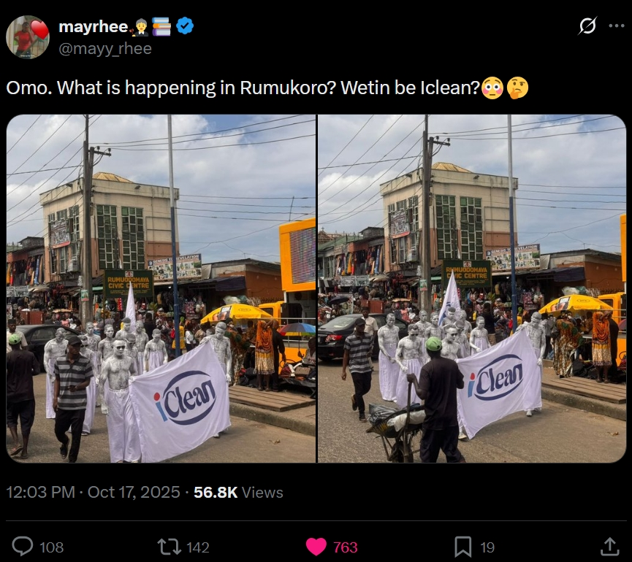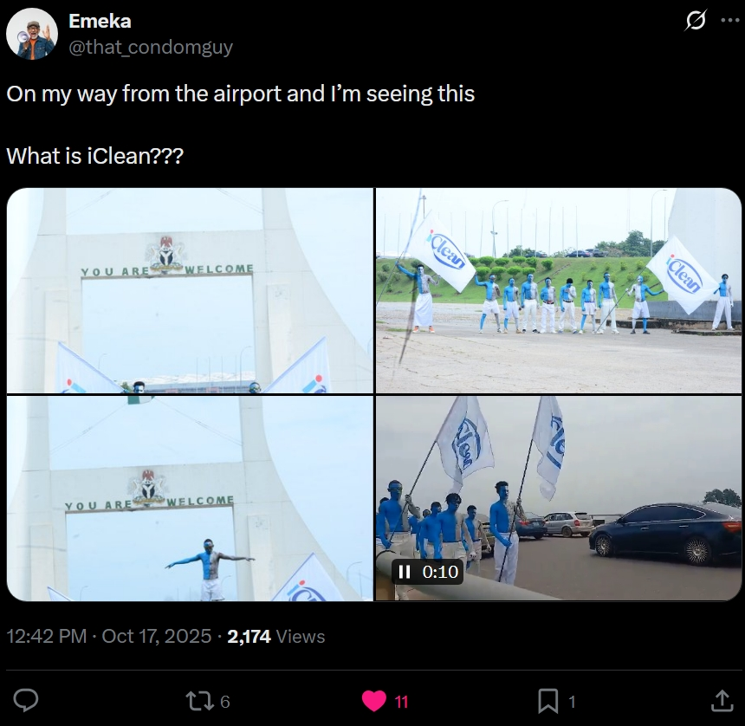

5. Key Insights
- Real rally images added authenticity and drove higher engagement rates.
- The mystery angle (“What is Iclean?”) successfully fueled organic speculation.
- Influencer and community amplification were crucial in sustaining the trend.
- Cross-city timing and visual consistency strengthened the campaign’s national footprint.

6. Recommendations (REDACTED)

7. Conclusion
The #IcleanIsComing campaign successfully achieved its purpose of building intrigue and brand visibility ahead of Iclean’s official reveal.
By merging offline activations with coordinated online amplification, the campaign created a national moment of curiosity that positioned Iclean as a name worth watching. The campaign created a unifying buzz across seven cities and trended at #5 nationwide.
This momentum forms a strong foundation for the brand’s next phase the reveal and product awareness campaign.

